GIT Hands on Lab 01.

1. Establish a local repository for your project with a descriptive name. Set up Git configurations by adding a username and email address. Display and modify the Git configurations, and verify if the changes are reflected in the .git/config file post-editing. Showcase the utilization of both Git Local and Global configurations.

Solved:

root@DESKTOP-SQGRBLG:/mnt/e/Git# vim usr_utiliza4lc_gl.txt

root@DESKTOP-SQGRBLG:/mnt/e/Git# git init

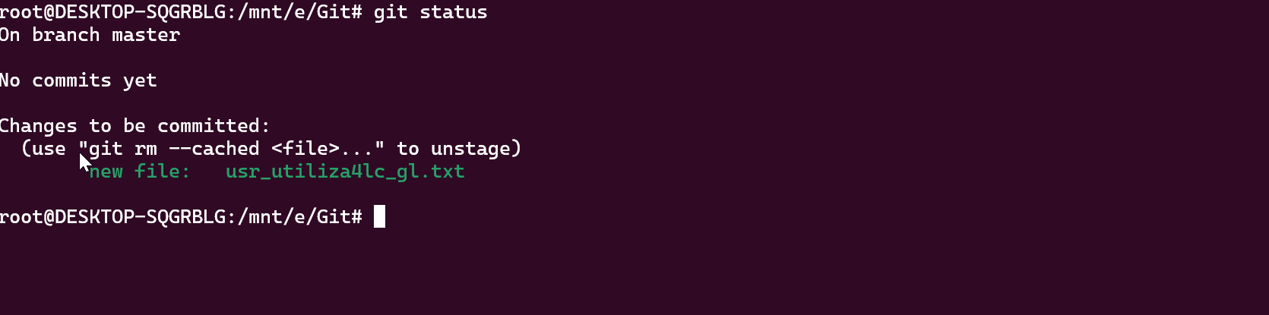

root@DESKTOP-SQGRBLG:/mnt/e/Git# **git config --global user.name "Ismail_Shaikh"**

root@DESKTOP-SQGRBLG:/mnt/e/Git#

root@DESKTOP-SQGRBLG:/mnt/e/Git# **git config --global user.email "ismail.shaih@cloudethix.com"**

root@DESKTOP-SQGRBLG:/mnt/e/Git#

root@DESKTOP-SQGRBLG:/mnt/e/Git# **git config -l**

user.name=Ismail_Shaikh

user.email=ismail.shaih@cloudethix.com

core.repositoryformatversion=0

core.filemode=false

core.bare=false

core.logallrefupdates=true

core.ignorecase=true

root@DESKTOP-SQGRBLG:/mnt/e/Git#

root@DESKTOP-SQGRBLG:/mnt/e/Git# git config --edit --global

root@DESKTOP-SQGRBLG:/mnt/e/Git#

root@DESKTOP-SQGRBLG:/mnt/e/Git#

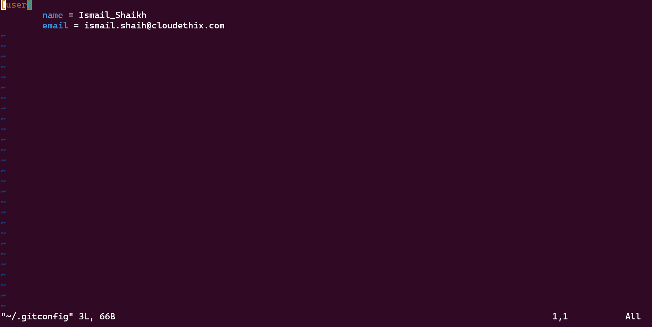

2. Set up a local repository for your project with a meaningful name. Explore the default branch in the local Git repository. Sequentially create five files, committing each with informative messages. Share the Git log output through multiple methods once the process is complete.

root@DESKTOP-SQGRBLG:/mnt/e/Git# mkdir Cloudethix_GitAssignment

root@DESKTOP-SQGRBLG://mnt/e/Git# **cd Cloudethix_GitAssignment/**

root@DESKTOP-SQGRBLG://mnt/e/Git/Cloudethix_GitAssignment#

root@DESKTOP-SQGRBLG:

root@DESKTOP-SQGRBLG:

To see Git Branch name:

root@DESKTOP-SQGRBLG://mnt/e/Git/Cloudethix_GitAssignment# git branch

* master

root@DESKTOP-SQGRBLG://mnt/e/Git/Cloudethix_GitAssignment#

**Creating a new Branch Name:**

root@DESKTOP-SQGRBLG://mnt/e/Git/Cloudethix_GitAssignment# git branch DevOps_Git

root@DESKTOP-SQGRBLG://mnt/e/Git/Cloudethix_GitAssignment# git branch

**DevOps_Git**

* master

root@DESKTOP-SQGRBLG://mnt/e/Git/Cloudethix_GitAssignment#

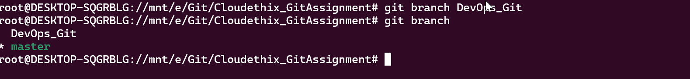

Adding files to git

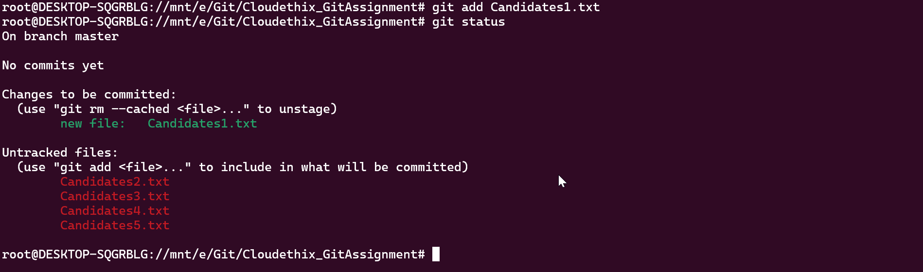

root@DESKTOP-SQGRBLG://mnt/e/Git/Cloudethix_GitAssignment# **git commit -m** "There are 9 Canidates are in file"

[master (root-commit) 92d09df] There are 9 Canidates are in file

1 file changed, 10 insertions(+)

create mode 100644 Candidates1.txt

root@DESKTOP-SQGRBLG://mnt/e/Git/Cloudethix_GitAssignment# git status

On branch master

Untracked files:

(use "git add <file>..." to include in what will be committed)

Candidates2.txt

Candidates3.txt

Candidates4.txt

Candidates5.txt

nothing added to commit but untracked files present (use "git add" to track)

root@DESKTOP-SQGRBLG://mnt/e/Git/Cloudethix_GitAssignment#

root@DESKTOP-SQGRBLG://mnt/e/Git/Cloudethix_GitAssignment# git log

commit 92d09df038882d9c8acfcaa918ae84945eb24cab (HEAD -> master)

Author: Ismail_Shaikh <ismail.shaih@cloudethix.com>

Date: Wed Jan 3 14:10:52 2024 +0530

There are 9 Canidates are in file

root@DESKTOP-SQGRBLG://mnt/e/Git/Cloudethix_GitAssignment#

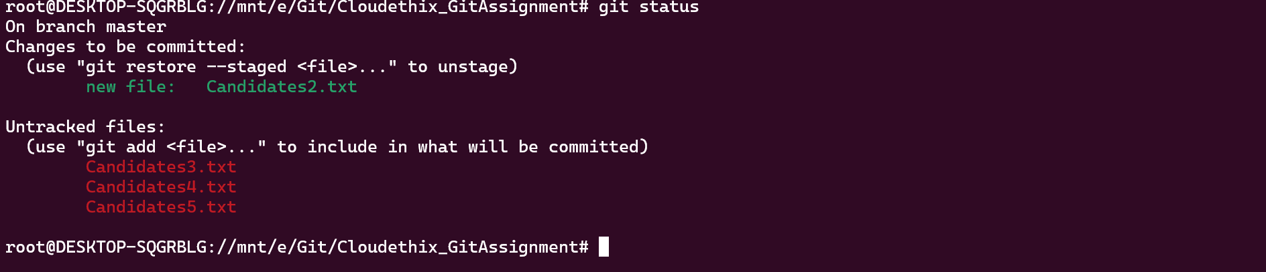



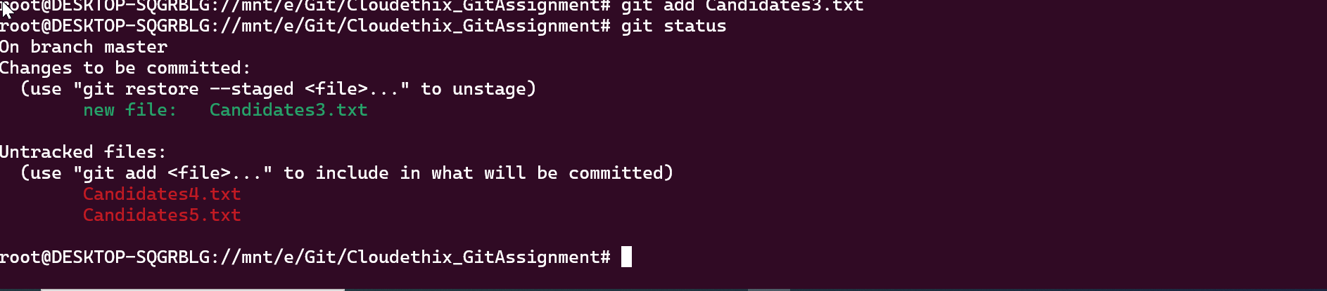



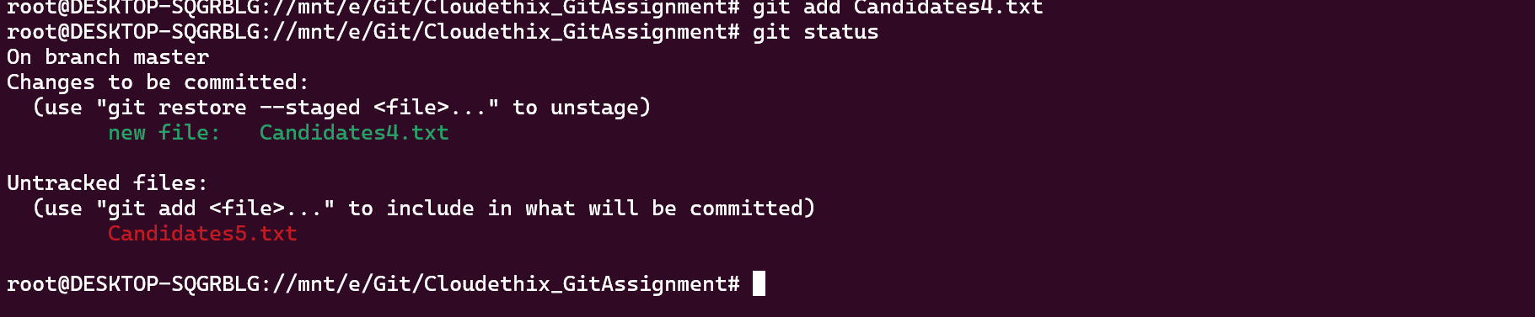



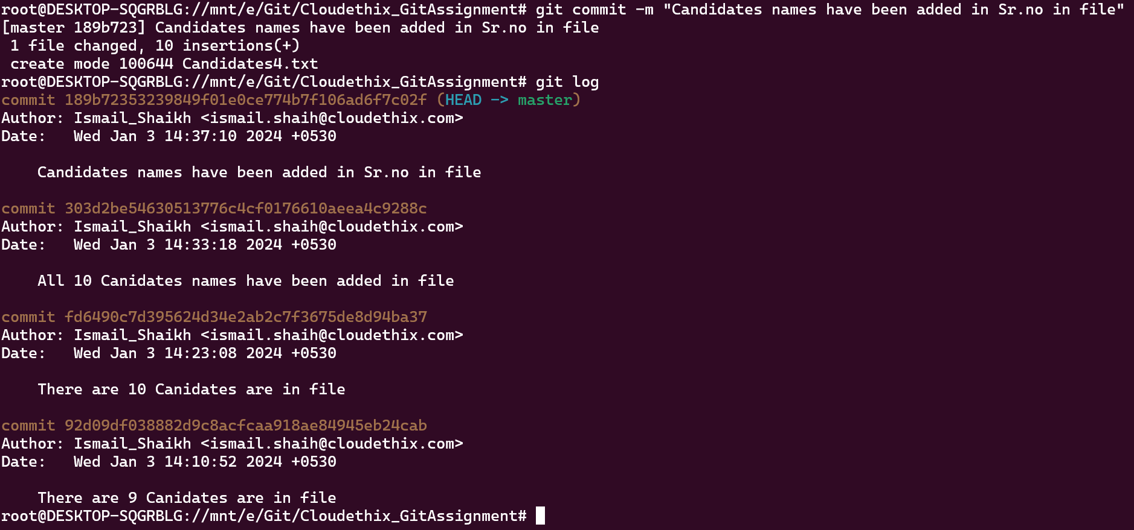

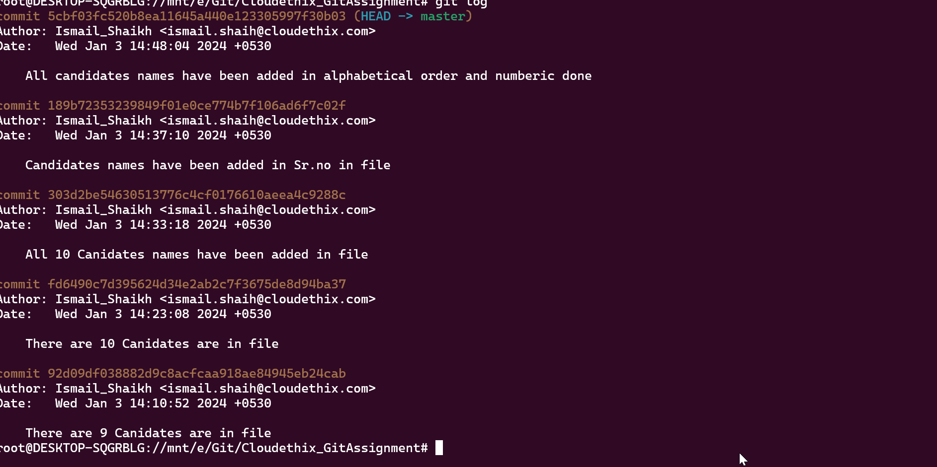

4. Establish a local repository for your project with a descriptive name. Illustrate the implementation of a Git-Ignore file by committing multiple files to the local repository.

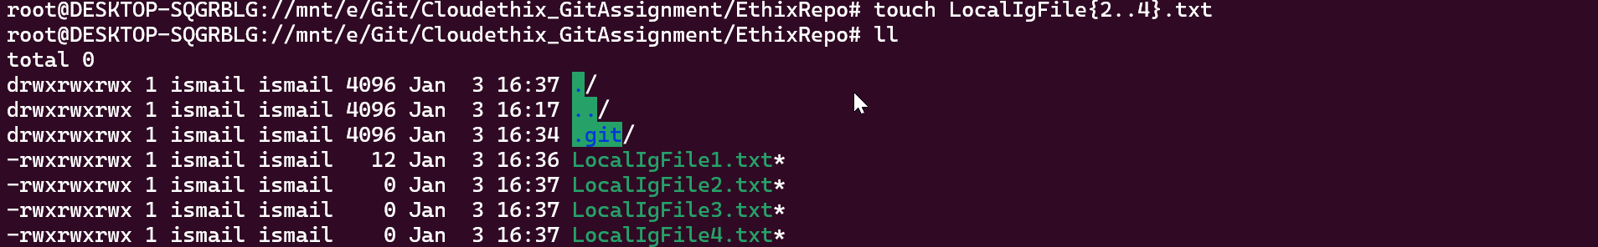

root@DESKTOP-SQGRBLG://mnt/e/Git/Cloudethix_GitAssignment/EthixRepo# **git add .**

root@DESKTOP-SQGRBLG://mnt/e/Git/Cloudethix_GitAssignment/EthixRepo# **git status**

